Prep list
Question 1


trial
V

V
Question 2

No. | Material/Apparatus for each candidate | Quantity
1 | Mung bean seeds (Vigna radiata) previously soaked for 24 hours in tap water | 15
2 | Soda lime pellets in a capped container labelled:  “Soda lime, harmful, corrosive” | 10 g
3 | Respirometer | 1
4 | Stopwatch | 1
5 | 30 cm ruler (mm) | 1
6 | Colored solution in a small container labelled “dye”  - Water with red or blue food dye added | 5 cm³
7 | Marble-size ball of Plasticine® | 1
8 | Small ball of cotton wool (50-cent coin size) | 1
9 | Blunt forcep | 1
10 | Safety glasses | 1
11 | Latex gloves | 1 pair
12 | Spatula | 1
13 | Paper towels | 1 pack
14 | Glass rod | 1
15 | White paper | 1
16 | Mounting needle | 1

Instruction for preparation
Mung beans
- Container used to be large enough for the expansion of the beans
- Water height just enough to cover the beans

Soda lime
- Pellets of soda lime can be packed in advance in air-tight plastic containers

Respirometer
- 20 cm³ syringe
- 20 cm length capillary tube of 1mm bore
- Plastic tubing

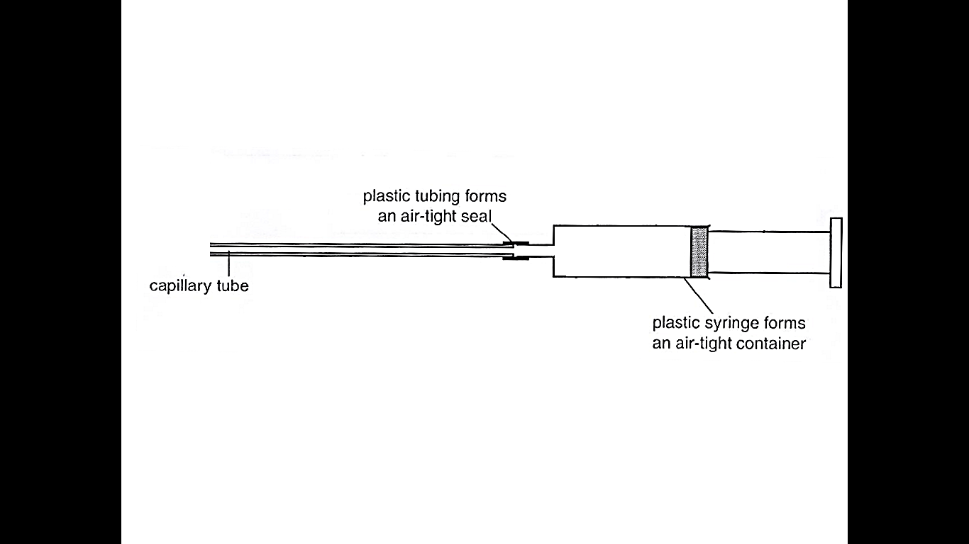
- Syringes used should be air-tight plunger that does not leak when tested by immersing in water.
- Tubing must be tight enough to prevent air leakage. This can also be tested by immersing the joint in water.

Question 3

Each candidate
- 1x Microscope with low and high power objective lens.
- 1 x 1mm stage micrometer
- 1 x ruler
- Slide on Zea Mays Roots

